1. List the month name and number of employees hired in each month and ignore the year factor Note: Two different years but the same month's hired employee count should be summed together to get the total of employees hired in the respective month.

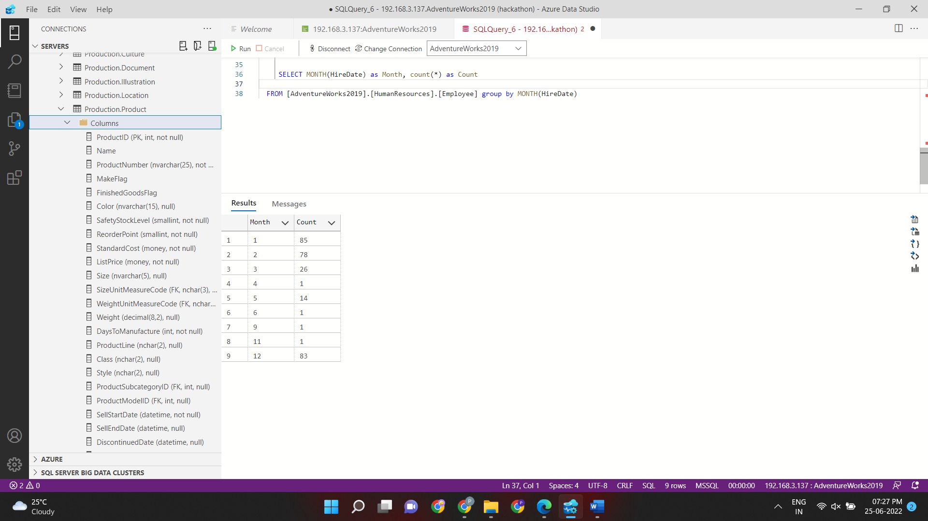

2. Lis t d e p a r t m e n t n a m e, a n d t h e n u m b e r o f e m plo y e e s hir e d in e a c h d e p a r t m e n t y e a r - wis e.

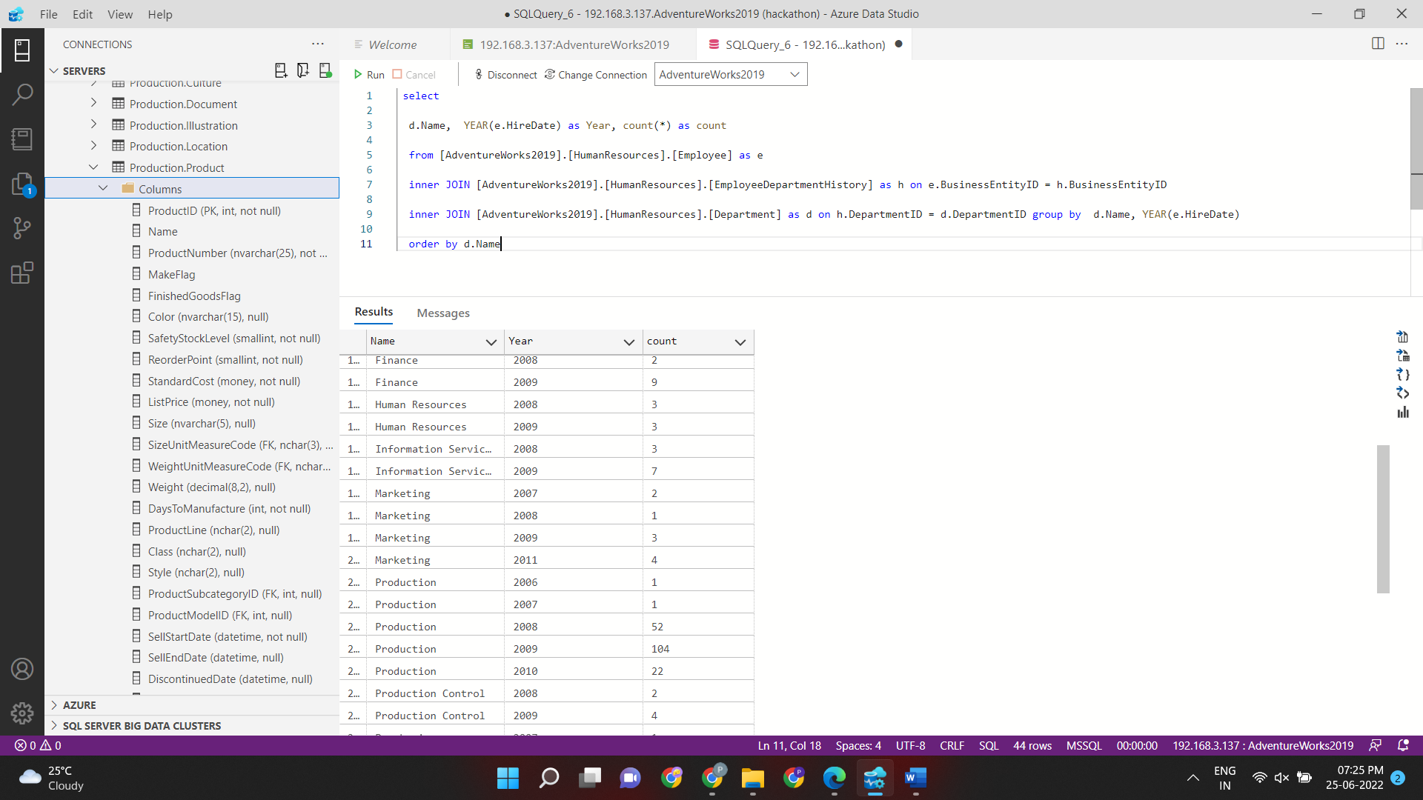

3. List the person and their country region name who is not an employee and their name starts with the character “S”

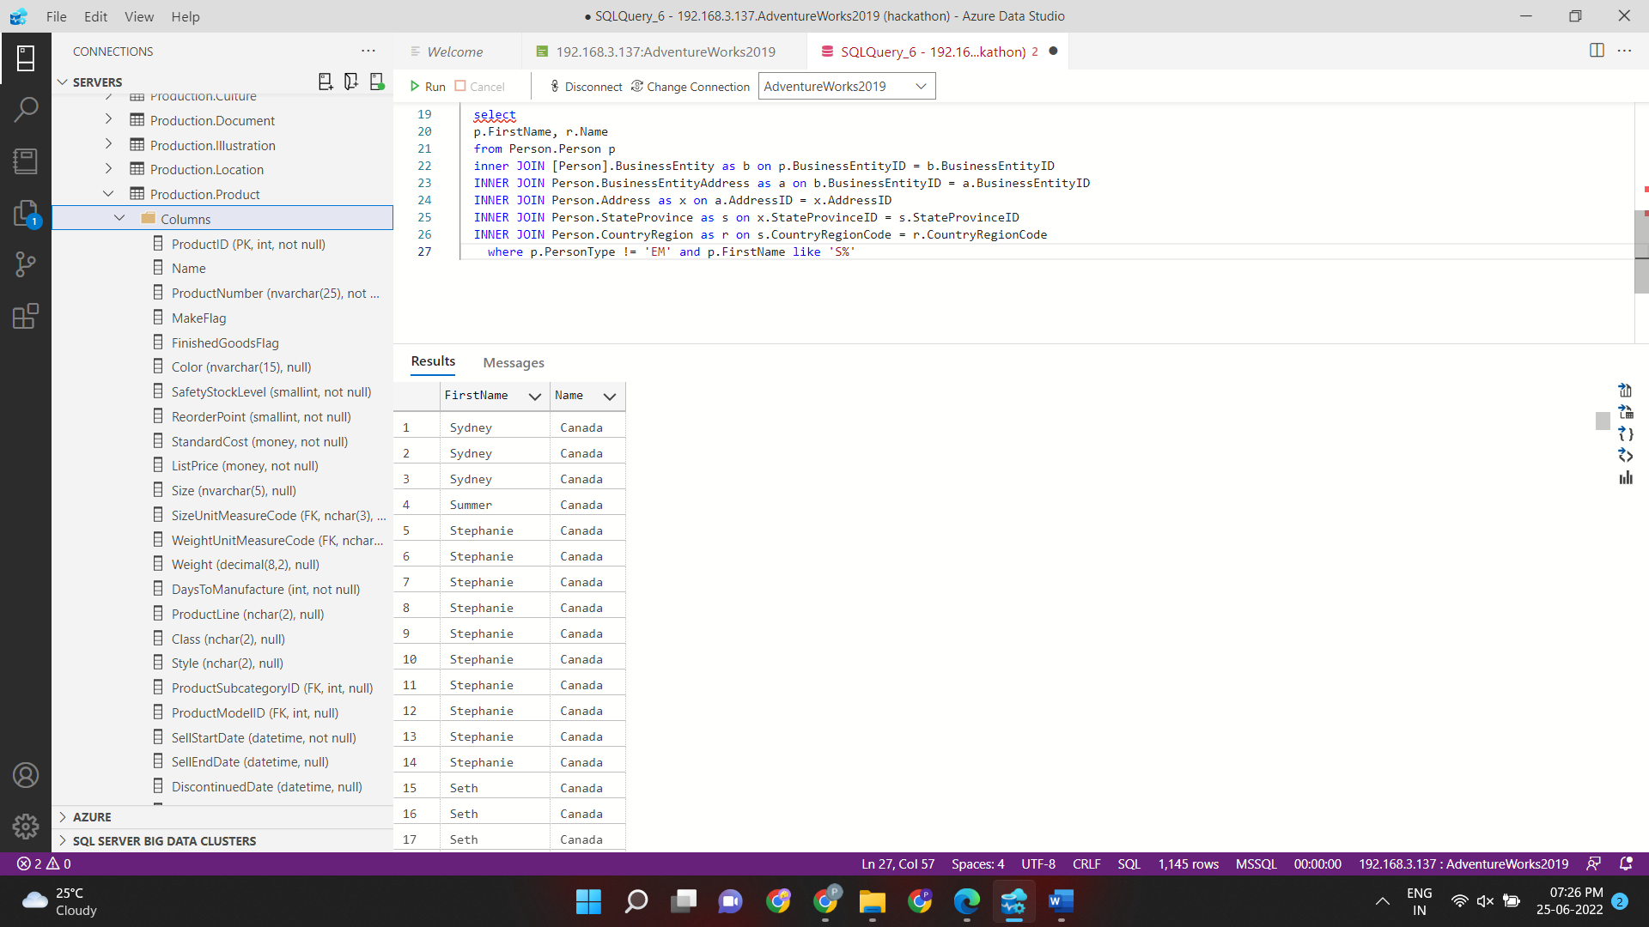

4. Each employee has an organization level. The organization-level provides details about employee senior. Organization level is mapped with the business_entity_id column of the employee table to get detail about seniors. List all senior employee names, job titles, organization level, and a number of immediate reporting employees.